  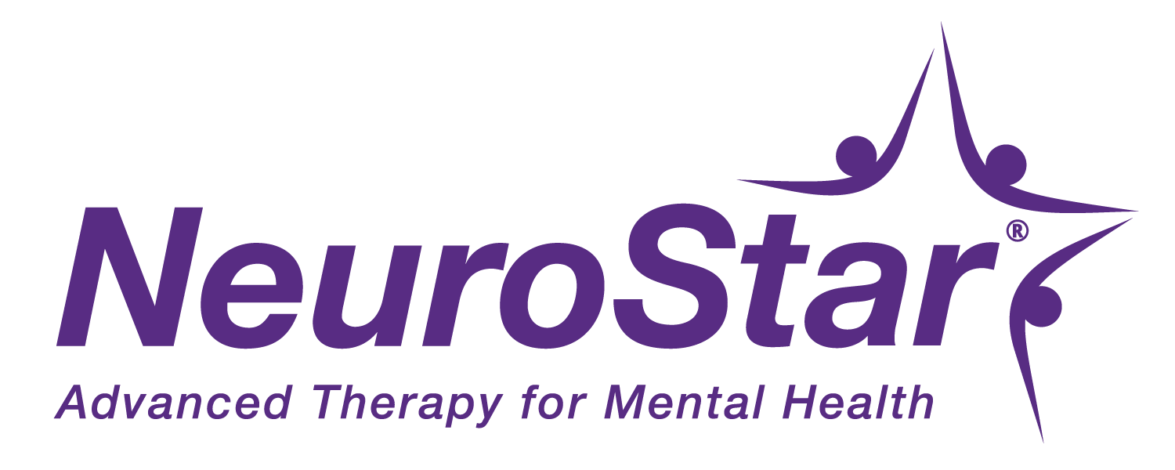
   |  |  | 

Dear [XXXX],

May is National Mental Health Awareness Month in the US, and we're working with NeuroStar and Drew Robinson to raise awareness about mental health.

  
  Drew was drafted by Major League Baseball in 2010 and was on a path to making a big impact. But behind the scenes, Drew was also battling major depression. After trying multiple medications that didn't successfully relieve his depression, Drew felt hopeless and, in the spring of 2019, he tried to take his own life.

But Drew's story doesn't end in tragedy. Drew survived and was able to find a doctor who understood his struggle. Drew's psychiatrist told him about a new possibility for treating his depression: NeuroStar TMS, a non-drug treatment for major depression, without systemic side effects of medication. Drew quickly recognized this was the chance he needed, and in May of 2022 Drew began NeuroStar TMS treatment.
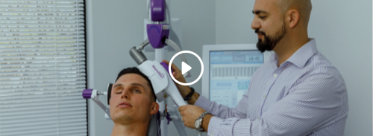

Click the link below to watch a short clip of Drew's NeuroStar Journey.
Watch the video

Antidepressants work for a lot of people, but when they don't it can be hard to know where else to turn. Fortunately, NeuroStar TMS has helped thousands of people just like Drew, for whom antidepressants didn't prove effective. At [Clinic Name], we're proud to offer NeuroStar TMS, and to be working with Drew and NeuroStar to make sure everyone who needs it knows about the possibility NeuroStar provides.

  National Mental Health Awareness Month is a perfect time to learn about all your treatment options. This simple 10-question survey can help you assess your options for depression treatment, including NeuroStar TMS.
  Take the PHQ-10 Assessment
  

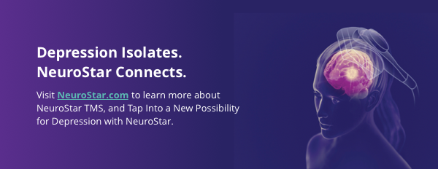

Call us today at [000-000-0000] to schedule your free consultation.

Signature

NeuroStar Advanced Therapy for Mental Health is available by prescription only. A doctor can help decide if NeuroStar is right for you. Results may vary. Visit NeuroStar.com for safety information and indications for use.
53-51377-000 Rev A

